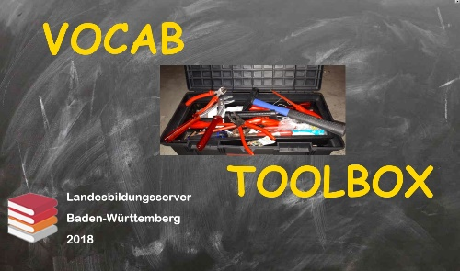
Vocab Toolbox: German "lassen"
Exercises

Tick ☒ the correct English translation!

- Sie ließen uns draußen in der Kälte warten.
- They let us wait outside in the cold.
 They made us wait outside in the cold.
 They waited outside in the cold.
 They waited for us outside in the cold.

- Mein Chef ließ mich heute früher gehen.
 My boss made me leave earlier today.
 My boss let me leave earlier today.
 My chef left me earlier today.
 My chef let me leave earlier today.

- Du solltest deine Haare bei einem richtigen Friseur schneiden lassen.
 You should have your hair cut at a proper hairdresser's.
 You should let your hair cut at a proper hairdresser's.
 You should make your hair cut at a proper hairdresser's.
 You should have cut your hair at a proper hairdresser's.

- Wir haben ein paar Broschüren für Sie drucken lassen.
 We let some brochures printed for you.
 We have printed some brochures for you.
 We have had some brochures printed for you.
 We made some brochures print for you.

- Lass mich in Ruhe und kümmere dich um deinen Kram!
 Let me alone and mind your own business.
 Make me alone and mind your own business.
 Leave me and mind your own business.
 Leave me alone and mind your own business.

Vocab Toolbox: German "lassen"
Solutions Sheet

- Sie ließen uns draußen in der Kälte warten.
- They let us wait outside in the cold. ➔ This is not about giving permission to wait outside in the cold!
☒ They made us wait outside in the cold.
 They waited outside in the cold.
 They waited for us outside in the cold.

- Mein Chef ließ mich heute früher gehen.
 My boss made me leave earlier today. ("He forced me to leave….")
☒ My boss let me leave earlier today.
 My chef left me earlier today. "chef" means "professional cook"!
 My chef let me leave earlier today.

- Du solltest deine Haare bei einem richtigen Friseur schneiden lassen.
☒ You should have your hair cut at a proper hairdresser's.
 You should let your hair cut at a proper hairdresser's.
 You should make your hair cut at a proper hairdresser's.
 You should have cut your hair at a proper hairdresser's. ➔ This is a present perfect form and means "You should have done the job at a hairdresser's shop"

- Wir haben ein paar Broschüren für Sie drucken lassen.
 We let some brochures printed for you.
 We have printed some brochures for you. ➔ "Wir haben ein paar Broschüren für Sie gedruckt!"
☒ We have had some brochures printed for you. ➔ We gave the job to someone else.
 We made some brochures print for you.

- Lass mich in Ruhe und kümmere dich um deinen Kram!
 Let me alone and mind your own business.
 Make me alone and mind your own business.
 Leave me and mind your own business.
☒ Leave me alone and mind your own business.

