Identification Key: Macroinvertebrates in moving water |  |  |  | 
Sven Gemballa • University Tübingen • Institute of Zoology
Translation: Martin Rausch, Schickhardt-Gymnasium Stuttgart
In Collaboration with Elke Tetens, Königin-Olga-Stift Stuttgart
1 With shell 2
1* Without shell ............................................................................ 4
2 Shell consisting of two halves, pea-sized  European fingernail clam (Sphaerium) (Fig. A)  2* One shell only 3 |  |  | 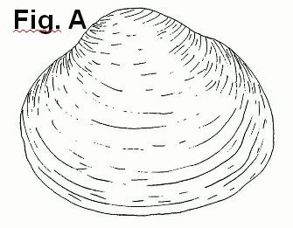
3 Shell cone-shaped Limpet (Ancylus) (Fig. B)  3* Shell spiral-shaped other fresh water snails (Fig. C) |  |  | 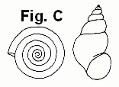  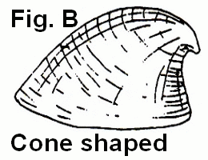
4 Body not segmented, flat and contractible, rear end pointed, front end often with a distinct head and with small eyes  .................................................flatworms (Planaridae, Fig. D)  4* Body segmented ...................................................... 5 |  |  | 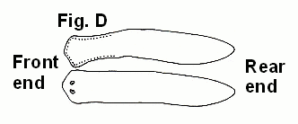
5 Front end and rear end with sucker, moves by means of the suckers or by snake-like movement.Leech (Hirudinea, Fig. E)  5* Front end and rear end without suckers .................................. 6 |  |  | 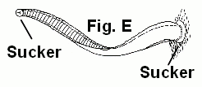
6 Always without segmented legs and without distinct head, body with more than 15 segments  ...........................Ringed worms (Oligochaeta, Fig. F)  6* Body segmented, always with fewer than 15 body segments  7 |  |  | 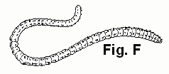
7 More than 3 pairs of legs 8
7* Never more than 3 pairs of legs ( = insect larvae).................10
8 Body higher than wide, lying on its side  Scud (Gammarus, Fig. G)  8* Body not higher than wide ...................................................... 9 |  |  | 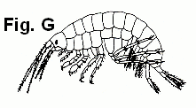
9 Front legs with claws Crayfish (Fig. H)  9* Front legs without claws ................................................  ..................................................Sowbug (Asellus, Fig. I) | 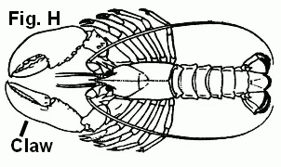 |  |  |  | 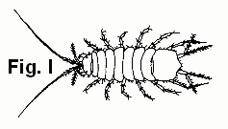

10 Insect larva without segmented legs, some with unsegmented small prolegs (Fig. K1) 11
10* Larva with segmented legs ....................................................17
11 8 pairs of unsegmented small prolegs with hooks, abdomen with two tail filaments, back with small hooks .....................  ............................................. Ibis fly (Atherix spec., Fig. K1)  11* No more than 2 or 3 pairs of small prolegs 12 |  | 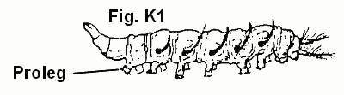
12 Rear end wider than front end (Fig. K2) and with a circle, head with two retractable fans .......  ............................. Blackflies (Fam. Simuliidae; Fig. K2)  12*Body different ...................................................................... 13 |  | 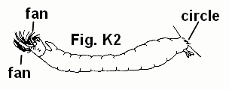
13 End of abdomen elongated to a thin snorkel with two gill tubes at the basis of the snorkel ............................................  ........... Phantom crane flies (Fam. Ptychopteridae; Fig. K3)  13* Body different ......................................................................13 |  | 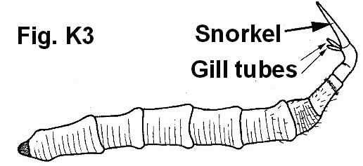
14 Respiratory opening at end of abdomen surrounded with up to 6 fingerlike projections ...................................................... 15  14* Abdomen different ............................................................... 16 |  | 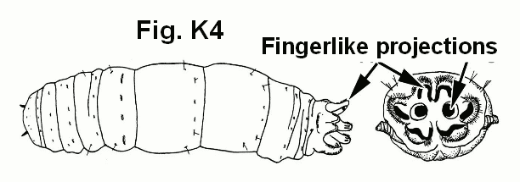
15 End of abdomen with six projections around respiratory openings ....................Crane Flies (Fam. Tipulidae; Fig. K4)  15* End of abdomen with fewer than 6 projections .....................  .....................................................Fam. Limoniidae; Fig. K5 |  | 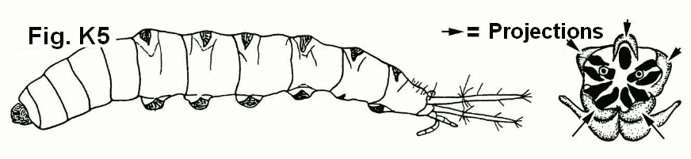
16 Body slim, a pair of prolegs on the first segment behind the head and on the last segment of the abdomen .......................  ...............Non-biting midges (Fam. Chironomidae; Fig. K6)  16* Body different ......... .....Other flies or mosquitoes (Diptera) |  | 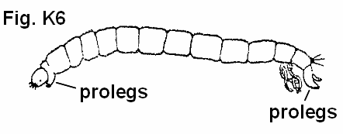
17 Compound eyes, older larvae with wing buds (Fig. L1) ... 18  17* Simple dot-like eyes (no compound eyes), older larvae without wing buds ……………………………………….. 26 |  | 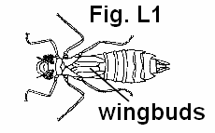
18 Abdomen with two or three long, hair-like tail filaments …19  18* Tail filaments very short (larvae of Dragonflies, Fig. L1) or 3 longer tail filaments (larvae of Damselflies, Fig. L2) .  Dragonflies (Anisoptera, Fig. L1) and Damselflies (Zygoptera, Fig. L2) (Order Odonata) |  | 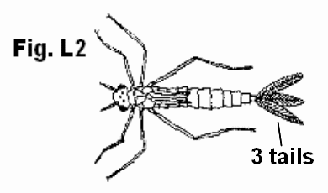
19 5 – 7 segments of abdomen with feathery or flat gills, always with 3 tail filaments Mayflies (Ephemeroptera; Fig. M1-5) 20
19* Abdomen without gills, no more than two segmented, hair-like tail filaments Stoneflies (Plecoptera, Fig. N1-3)……..24

20 Gills held over back of body, maxillae longer than the head  ……..Burrowing Mayflies (Fam. Ephemeridae; Fig. M1)  20* Maxillae shorter than the head ……………… 21 |  | 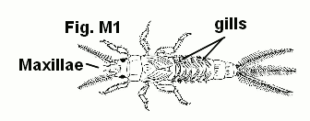
21 Body flattened , abdomen with flat gills (Fig. M2, M3), eyes on the upper side of the head (Fig. M3) or on the sides (Fig. M2) 22  21* Body slim, gills flat or simple filaments or tufts of filaments, eyes always on the side of the head (Fig. M4, M5) 23 |  | 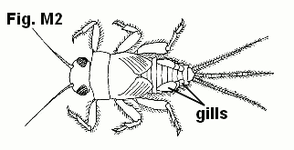
22 Body with hair, live animals have almost always sand grains on their body, eyes on the side of the head  Spiny Crawler Mayflies (Fam. Ephemerellidae; Fig. M2)  22* Body flattened, without hair, no sand grains, tufts of filaments under the long and flat gills, eyes on the upper side of the head  Flat-headed mayflies (Fam. Heptageniidae; Fig. M3) |  | 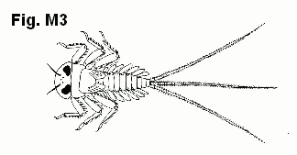
23 Gills consisting of single hairlike filaments or tufts of filaments, outer tail filaments with hair on all sides  Prong-gilled mayflies (Fam. Leptophlebiidae; Fig. M4)  23* Gills flat, outer tail filaments with hair on inside only ……  …………………Small mayflies (Fam. Baetidae; Fig. M5) |  | 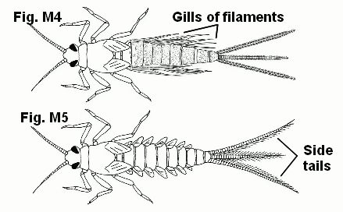
24 Third segment of feet much longer than first and second together. Lower lip with one pair of projections (Fig. N1_1) Fam. Perlidae+ Perlodidae; Fig. N1)  24* First two segments of feet together nearly as long as the 3. segment (1. segment always longer than 2. segment), lower lip with two pairs of projections (Fig.N2_3) ………………. 25 |  | 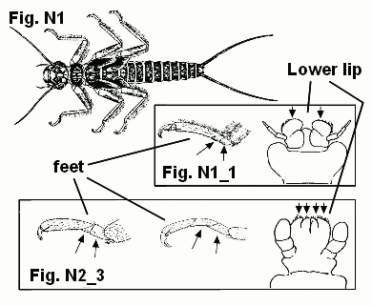
25 Body very slim, wing buds parallel to body, hind legs short and not longer than abdomen when stretched  Small winter stoneflies Fam. Leuctridae+ Capniidae; Fig. N2)  25* Wing buds sticking out from the body sides; hind legs long, as long as or longer than the abdomen when stretched  Spring stoneflies Fam. Nemouridae+winter stoneflies Fam. Taeniopterygidae; Fig. N3) |  | 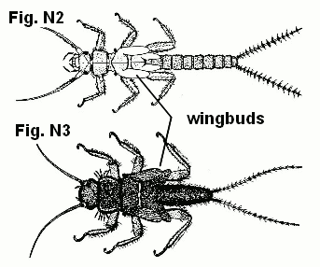
26 End of abdomen with a pair of hooks, animals living free or in cases built by themselves out of sand or organic material (Caddisflies, Trichoptera) 27  26* No hooks at the end of abdomen 30 |  | 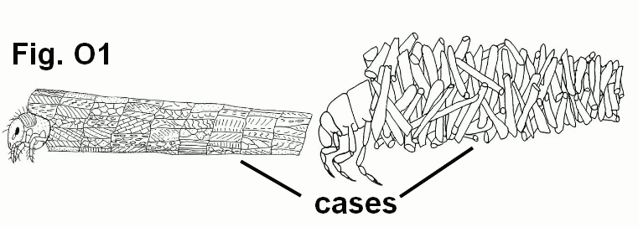
27 Larva in a case of sand or organic material ……………
………………………………Species with cases (Fig. O1)
27* Larva without case, free living species ………………….. 28
28 Abdomen cylindrical with tufts of branched gill filaments on the lower side of the abdomen, rear end bent down, first three segments behind the head with dark plates on the back, two short tails each with one claw  ………Net-spinning caddisfly (Hydropsyche spec; Fig. O2)  28* Body different …………………………………………… 29 |  | 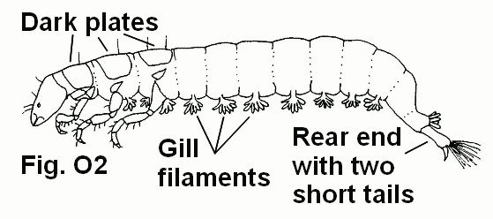
29 Abdomen with tufts of branched gill filaments on the side of the abdomen, only first segment behind the head with a dark plate on the back, often light coloured or greenish, Rhyacophila spec.; Fig. O3  29* Colour different ….Other free living larvae of caddisflies |  | 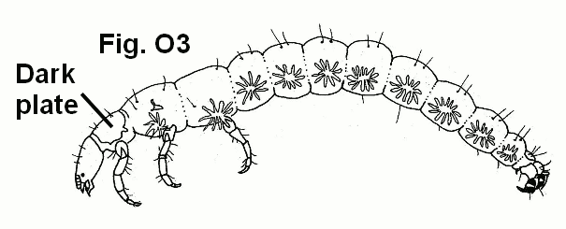
30 Abdomen with segmented gills and single segmented tail filament (Megaloptera)  Alderfly larva, Sialis spec.; Fig. P)  30* Abdomen without gills or with unsegmented gills  Beetle larvae (Coleoptera) …………………………….. 31 |  | 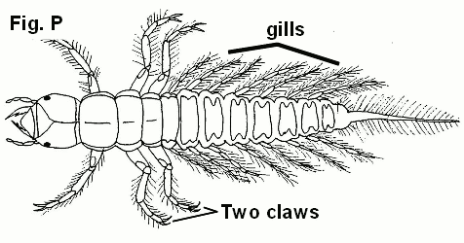
31 Legs with 5 segments (plus claws), Fig. Q1_2' 32  31* Legs with four segments (plus claws) Fig. Q3_4' 33 |  | 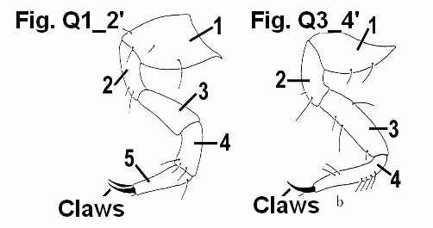
32 Abdomen with unsegmented filaments extending from side of abdomen…… Whirligig Beetles (Fam. Gyrinidae; Fig. Q1)  32* Abdomen without gills, long and pointed mandibles  ……..Predaceous diving beetles (Fam. Dytiscidae; Fig. Q2) |  | 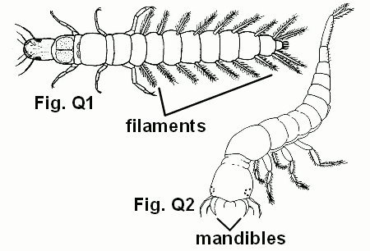
33 Animals with long and slim antennae  Marsh beetles (Fam. Scirtidae; Fig. Q3)  33* Animals of diverse body shapes, antennae short (less than 5 segments) ………………………………………………..34 |  | 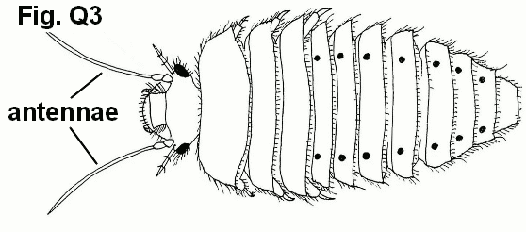
34 Abdomen with anal gills in the last segment, anal gills are protruded and withdrawn rhythmically for respiration  ………………………………Fam. Elmidae; Fig. Q4)  34* Animals different ……………… Other beetle larvae |  | 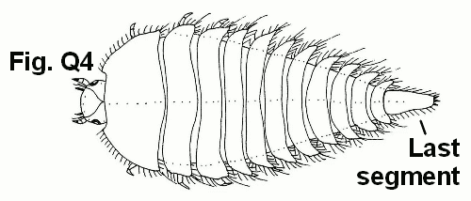

abdomen – Hinterleib | maxillae – spez. Mundwerkzeuge von Insekten
branched - verzweigt | pointed - zugespitzt
claw – Schere, Kralle | to protrude - überragen
compound eye – Facettenauge | rear end – Hinterende
fan – Fächer | retractable – einziehbar
feathery - federähnlich | slim – schlank
gill – Kieme | to stretch - dehnen
hook – Haken | sucker – Saugnapf
lip - Lippe | tuft - Büschel
mandibles – spez. Mundwerkzeuge von Insekten | wing bud – Flügelanlagen
 | snorkel -Schnorchel

Project „BiodivA“ - „Biodiversity and Evolution“:  Grammar schools Maria von Linden Gymnasium Calw & Schickhardt Gymnasium Stuttgart funded by | 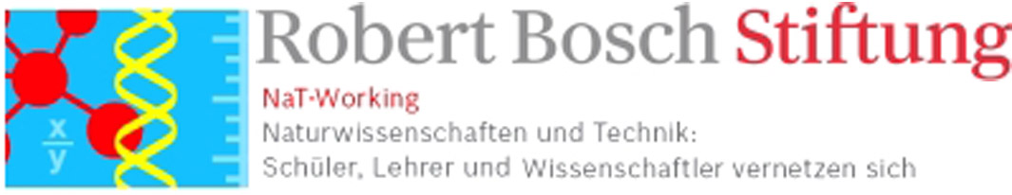

Changed after S. Gemballa & F. Schermutzki, PdN Biologie 53 (2): 19- 27 (2004) und W. Rähle (unpubl.; Universität Tübingen)
Imagines are not included in this identification key.

