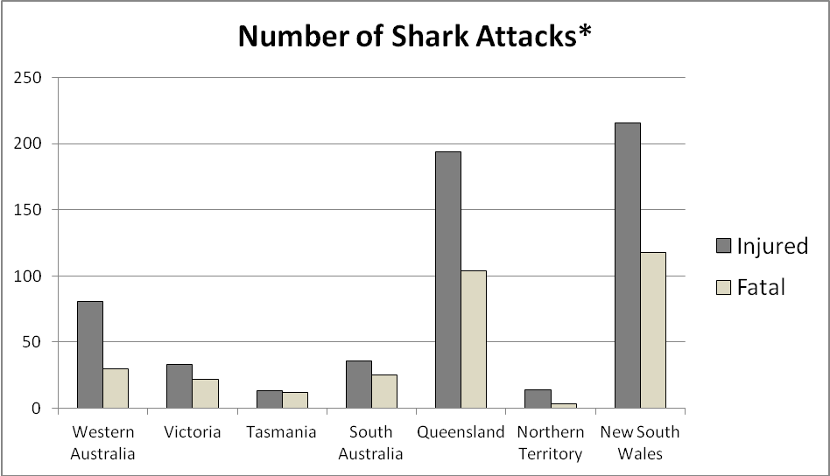

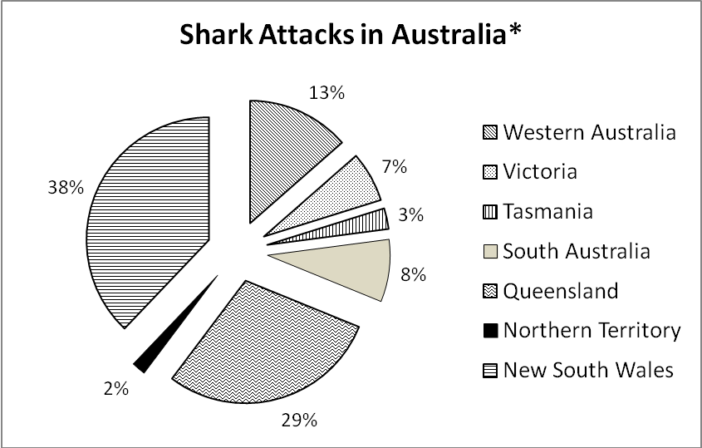

*total number of reported shark attacks in Australia

Source: Shark Attacks and Related Incidents File (access 2 October 2014)

