The passive voice in the simple present – Let's bake scones!

Ingredients for our tea time
Scones | Clotted cream substitute and jam
- 500 g flour  - 120 g cold butter  - 3 teaspoons sugar  - 1 packet of baking powder  - a pinch of salt  - 300 ml milk  - a handful raisins  - 1 egg | - 250 g mascarpone  - 200 g (single) cream (Schlagsahne)  - strawberry or rasperry jam
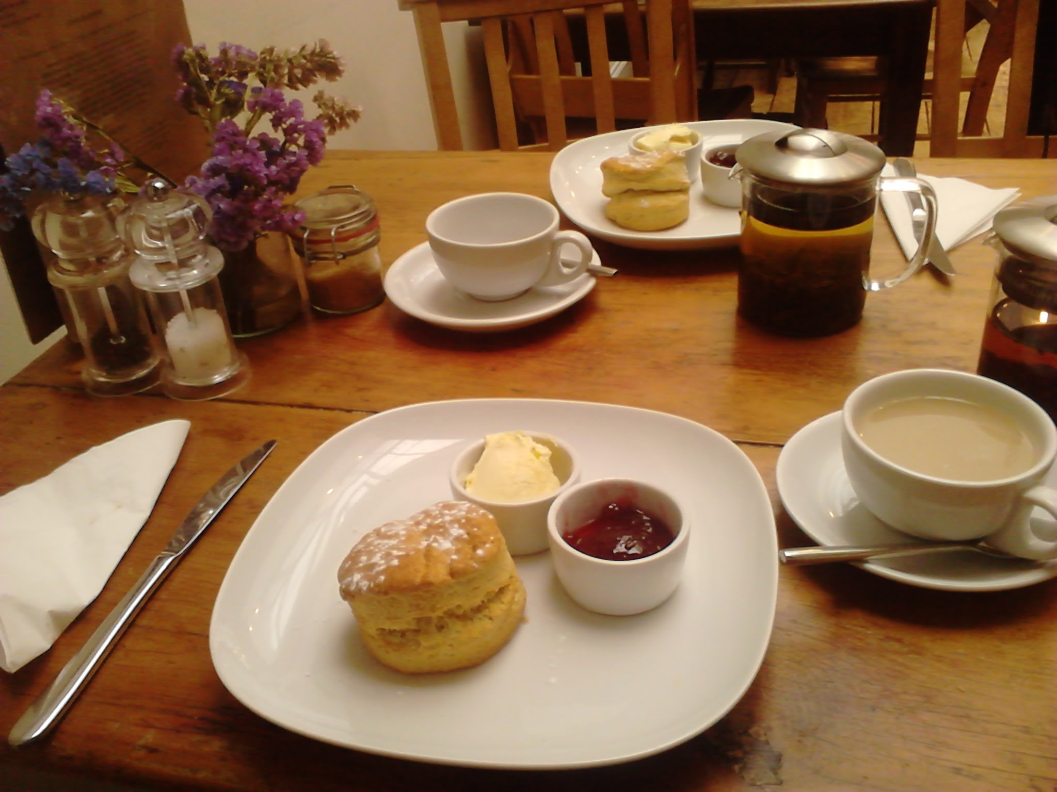
Preparation | Use the scones recipe to make passive constructions. Change the coloured verbs only.
First, Lilibet lays the raisins in milk.  Step 1  Then she sieves the flour and the baking powder in a large bowl and shoots in the sugar and the salt. Lilibet cuts the butter into cubes and also adds them to the mixture.  Step 2  Lilibet preheats the oven to fan 200 degrees. She rubs the mixture of flour, baking powder, butter and the raisins with milk together. She uses her fingers and makes a fine crumbed dough. She must not overwork the ingredients at this point or she will toughen the dough.  If she finds a few flakes of butter, she does not mind, because they make the scones light and fluffy.  Step 3  Lilibet lifts the ball of soft dough out of the bowl and puts it on a lightly floured surface. She pats the dough gently with her hands to a thickness of about three centimetres. She cuts out the scones with a cutter or a glass (of about 6 centimetres in diameter).  Step 4  Lilibet places the scones on a baking sheet and glazes them with the whisked egg. She bakes them for about 12 minutes until they rise and she finds them golden. She cools the scones on a wire rack.  Step 5  Finally, Lilibet prepares the clotted cream. She mixes mascarpone and cream until she has a viscous mass. She then leaves this cream in a capped bowl in the fridge.  Lilibet serves the scones as fresh as she can, together with the clotted cream and the jam. | EXAMPLE: First, the raisins are laid in milk.  NOW YOU  Step 1  Then the flour and the baking powder ......................................... in a large bowl and the sugar and the salt ......................................... in. The butter ......................................... in cubes and …........ also ............................ to the mixture.  Step 2  The oven ......................................... to fan 200 degrees. The mixture of flour, baking powder, butter and the raisins with milk ......................................... together. Her fingers ................................................. and a fine crumbed dough .......................................... The ingredients ................................................. at this point or the dough .............................................. .  If a few flakes of butter ........................................., we do not mind, because the scones ......................................... light and fluffy this way.  Step 3  The ball of soft dough ......................................... out of the bowl and ......................................... on a lightly floured surface. The dough ......................................... gently to a thickness of about three centimetres. The scones ......................................... out with a cutter or a glass (of about 6 centimetres in diameter).  Step 4  The scones ......................................... on a baking sheet and ......................................... with the whisked egg. They ......................................... for about 12 minutes until they rise and they ......................................... golden. The scones ......................................... on a wire rack.  Step 5  Finally, the clotted cream .................................... . The mascarpone and cream .................................. until we have a viscous mass. Then this cream ...................................... in a capped bowl in the fridge.  The scones ......................................... as fresh as possible, together with the clotted cream and the jam.
Additional information
Traditionally, most Cornish people spread the jam first and then add a spoonful of cream. This method is commonly used in London, which could explain why the Queen's guests take their scones this way. In contrast, most Devonians cover each half of a scone with cream and then with jam.
Whichever method you follow – enjoy!

a substitute: ein Ersatz (Clotted cream ist in Deutschland sehr selten erhältlich, daher behelfen wir uns mit einem anderen Produkt.)
fan 200 degrees: 200 Grad Umluft – Umluft ist das Zeichen mit dem Ventilator
to toughen: zäh werden
a cutter: eine Ausstechform
viscous: dickflüssig

