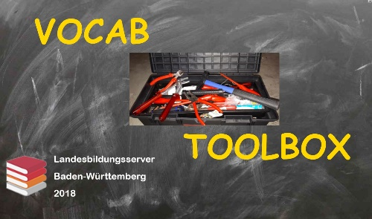
Vocab Toolbox: German "lassen"
Exercises

Tick the correct English translation!

- Sie ließen uns draußen in der Kälte warten.
- They let us wait outside in the cold.
They made us wait outside in the cold.
They waited outside in the cold.
They waited for us outside in the cold.

- Mein Chef ließ mich heute früher gehen.
My boss made me leave earlier today.
My boss let me leave earlier today.
My chef left me earlier today.
My chef let me leave earlier today.

- Du solltest deine Haare bei einem richtigen Friseur schneiden lassen.
You should have your hair cut at a proper hairdresser's.
You should let your hair cut at a proper hairdresser's.
You should make your hair cut at a proper hairdresser's.
You should have cut your hair at a proper hairdresser's.

- Wir haben ein paar Broschüren für Sie drucken lassen.
We let some brochures printed for you.
We have printed some brochures for you.
We have had some brochures printed for you.
We made some brochures print for you.

- Lass mich in Ruhe und kümmere dich um deinen Kram!
Let me alone and mind your own business.
Make me alone and mind your own business.
Leave me and mind your own business.
Leave me alone and mind your own business.

Vocab Toolbox: German "lassen"
Solutions Sheet

- Sie ließen uns draußen in der Kälte warten.
- They let us wait outside in the cold. This is not about giving permission to wait outside in the cold!
They made us wait outside in the cold.
They waited outside in the cold.
They waited for us outside in the cold.

- Mein Chef ließ mich heute früher gehen.
My boss made me leave earlier today. ("He forced me to leave….")
My boss let me leave earlier today.
My chef left me earlier today. "chef" means "professional cook"!
My chef let me leave earlier today.

- Du solltest deine Haare bei einem richtigen Friseur schneiden lassen.
You should have your hair cut at a proper hairdresser's.
You should let your hair cut at a proper hairdresser's.
You should make your hair cut at a proper hairdresser's.
You should have cut your hair at a proper hairdresser's. This is a present perfect form and means "You should have done the job at a hairdresser's shop"

- Wir haben ein paar Broschüren für Sie drucken lassen.
We let some brochures printed for you.
We have printed some brochures for you. "Wir haben ein paar Broschüren für Sie gedruckt!"
We have had some brochures printed for you. We gave the job to someone else.
We made some brochures print for you.

- Lass mich in Ruhe und kümmere dich um deinen Kram!
Let me alone and mind your own business.
Make me alone and mind your own business.
Leave me and mind your own business.
Leave me alone and mind your own business.

